Caring for those who care: Your wellbeing roadmap
Welcome to this personal wellbeing planner – a comprehensive guide designed to help you achieve your wellbeing goals and, ultimately, improve your quality of life.
Consider this guide your roadmap. It will take you step by step through a review process to help you identify what’s going well and what you’d like to work on to improve your wellbeing, and then support you to set goal to help you focus on key areas.
Critically, we draw on two well-established and highly regarded psychological approaches to health behaviour change throughout this guide: cognitive behavioural therapy and motivational interviewing. These approaches are useful for providing a practical framework that helps you not only set goals, but also address important factors such as your readiness and confidence to change, and any barriers you may experience.
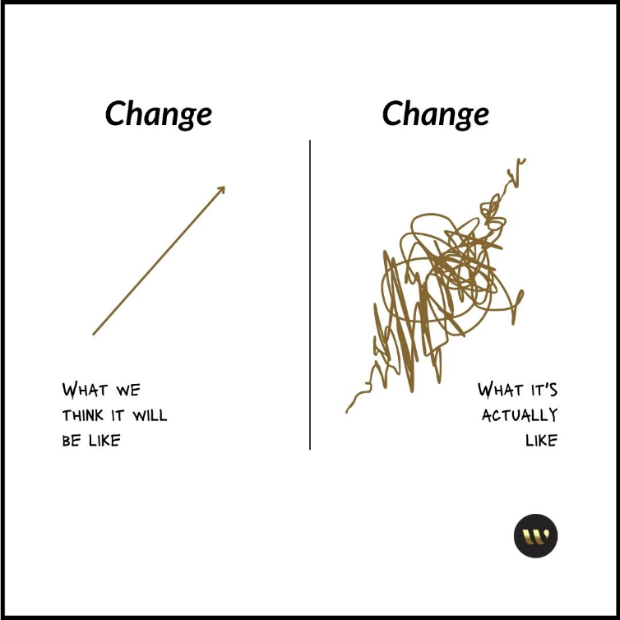
As many of us will have experienced before, setting and working towards goals is not always a straightforward process. It’s certainly not linear. Things come up from time to time that test our intentions, not matter how good they are. It’s important to know this is completely normal (see the diagram!).
To help you stay on track, or get back on track, consider:
- Who, within my life, can support me through this process?
- How can I adjust my environment to support me?

Using this planner
In terms of time allocation, some people may find it easier to complete this planner in one go, while others may find it takes a few sessions. It is entirely up to you. As a general guide, allow 30 to 45 minutes. Of course, there is no right or wrong. This is your planner.

Part 1: What does wellbeing mean to me?
To start, it’s helpful to understand what’s important to you when it comes to wellbeing. Wellbeing can mean different things to different people. An easy way to approach this is by thinking about wellbeing as a series of domains, or factors.

For this guide, we’ll focus on four domains: physical, mental, financial and social wellbeing. Feel free to add others (career wellbeing, spiritual wellbeing, or any others that particularly resonate)

Consider the following questions:
- What does each domain mean to you?

- In an ideal world, what would each domain look like for you if you felt healthy and well?

- If a friend was to see you thriving in each domain, what would they observe?

Part 2: Current wellbeing
Next, let’s take more of a deep dive on your level of wellbeing right now. You may like to use your answers in part 1 to help you.
Complete the following table as a review. Try to be as specific as you can. We’ve included some thought starters below this table to help you.
Questions | Your answers
What’s is good about your wellbeing right now? What are you happy with?
What has frustrated you? Or been challenging?
If you could rate each of the 4 domains of wellbeing above from 1-5 (5 being the best), where would you rate yourself?
What would you like your wellbeing to be like? What would you be able to do? What would it feel like?
What are, broadly, the top 3 wellbeing areas you’d like to focus on?

Here is some wellbeing thought starters, based on what other people have shared with us from developing their own wellbeing plans. These may be things you’re already doing, or be things you’d like to do more of:
- Mental wellbeing: make time for yourself • have fun, laugh • manage stress • regulate emotions • learn strategies to cope • explore thoughts and behaviours • engage in things you enjoy doing • seek advice or assistance
- Physical wellbeing: improve energy • increase flexibility • increase strength • increase cardiovascular fitness • increase incidental exercise/be less sedentary • reduce impact of injury/illness
- Social wellbeing: relationships with family • relationships with friends • relationships with colleagues • connect with the community • engage in hobbies / leisure activities • volunteer • celebrate milestones, festivals etc
- Financial wellbeing: • develop a budget or financial plan • review loans and debt • learn about spending habits • focus on investments

You may also like to consider:
Wellbeing risk factors: sleep quality/ quantity • fatigue • alcohol use • smoking • other recreational drug use • stressful situations • isolation • chronic stress or burnout
Improving your knowledge: know about your health conditions or challenges • know how to manage your symptoms • know about treatment options • know causes and risk factors • know where to get help • know who can support you
Managing health conditions or challenges: • seek advice • recognise your symptoms • monitor your symptoms • use an action plan to manage symptoms • manage symptoms effectively in a timely way • get assistance • attend appointments • undergo tests • take medication as prescribed • use aids / braces /dressings / equipment • follow rehabilitation plans

Part 3: My wellbeing priority areas
Now we’re ready to get really focused. But before we jump into goal setting, we want to take the time get more specific about what you’re aiming for and describe what life would be like for you if you improved a focus area. We want to get to the heart of why this change is important to you, and the benefits. This will help you to stay focused, especially when it feels hard.
To that end, challenges can arise. But knowledge is power – so if you can anticipate and work through potential barriers now, then you’re more likely to be successful.
Let’s start with exploring internal barriers. In the following table, you’ll consider these questions for each focus area:
- Readiness: How ready are you to make this change? Understanding your level of readiness enables you to gauge if you are prepared to embark on the journey. If you’re not ready, that’s ok. Importantly, it’s helpful to think through why that is.

- Importance: How important is making this change to you? Identifying the importance of the change helps you clarify your priorities and commitment to the process. If it’s not important, you’re not likely to concentrate on it. If you want to increase its importance, find a reason to change that’s compelling to you.

- Confidence: How confident are you to make this change? Assessing your confidence levels enables you to recognise and build on your strengths while addressing potential barriers. If you don’t feel confident, that’s ok. Find people who can help you, and consider what the smallest steps are that you can take to get started.

- Knowledge: How knowledgeable do you feel about this change? Gauging your knowledge about the change provides a foundation for informed decision-making and goal-setting. If knowledge is a barrier, who can help or where you can find more information?

Ability: How able are you make this change? Considering your ability to make the change acknowledges the practical aspects and resources needed to achieve your goals. What skills might you need to develop? How could you develop those skills?

- Supported: How supported are you to make this change? Lastly, recognising the level of support you have reinforces the significance of a supportive environment and network, which can greatly influence your success in implementing and sustaining the desired behaviour change. Social support is key. Find people who believe in you and your success.
Answering these questions is crucial as they provide valuable insights into your readiness, motivation, and self-efficacy.
Above all, be honest. By honestly addressing these potential barriers, you can lay the groundwork for a more effective and empathetic approach to achieving your goals and improving your overall wellbeing.
Finally, in this section, we’ll also look at external barriers or challenges as well. These may be barriers at work, or at home.
Activity: complete the following table.

My focus areas
 | Focus area: | What I’d like to achieve: | Potential barriers to my success | My self-assessment
1 | e.g. reduce stress at work | e.g. I’d like to reduce my stress response to things at work so that its more manageable and I still have energy at the end of the day. | e.g. workload is high, we’re short-staffed, not sure if I have enough support | 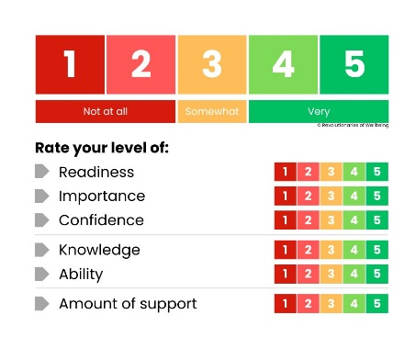
2
3

Part 4: MY PLAN
Now it’s time to put it all together. Considering your previous answers, use the table below to create your wellbeing plan.
 | WELLBEING GOAL | ACTIVITIES | SUPPORT AND RESOURCES | MEASURE SUCCESS | TIMESCALE
 | What areas of wellbeing would you like to work on? | What activities can I do to improve in this area? | What support and resources do I need to improve in this area? | How will know when I have achieved part or all this goal? | What is my timescale to complete my activities (e.g. 1-2 weeks, 1-6 months)
1 | e.g. mental wellbeing – stress at work | e.g. Make an appointment to see a mental health professional.  Make time to balance the stress with activities that help me to disengage from work (e.g. surfing) | e.g. use EAP service, talk to my family and friends | e.g. I will have had four sessions with EAP, and have strategies I’m effectively using to help me. | e.g. 3 months
2
3
 | Review timeframe | I will review this plan: / /

